.magnic.com/pmlat or_951778-63010. jpg 
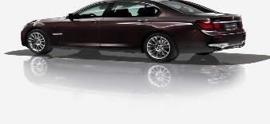
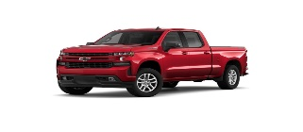
800 Park Avenue, 6th Floor,Utica, NY 13501
WE HAVE GREAT AUTO RATES
__________________________________________________________
FINANCE YOUR AUTO LOAN WITH US!
WE OFFER GREAT RATES!!!!!!
REFINACE YOUR CURRENT AUTO LOAN FROM ANOTHER LENDER

Finance a New or Used Auto Loan with us

USED AUTO NEW AUTO (2024 t0 2027)

36 months 8.75% (2014 to 2016) 36 months 4.00%

36 months 5.00% (2017 to 2023) 37-48 months 4.25%

37-48 months 5.25 % (2017 to 2023) 49-72 months 5.00%
49 -84 months 5.50%

Finance $40,000 to up $65,000 with a term of 84 months 5.00%

Unsecured Loans: Vacation Loan Special

10% up to $9,000. $1,000 to $3,000 for 1 year 6.5%
***Stop in or call us at (315) 798-5741 for more information ***

ALL LOANS MUST STAY WITHIN CREDIT LOAN GUIDELINES ANDAPPROVAL BY OUR POLICY.

